Near-Death Experiences and Christianity

Shawn Nelson
AP 901: Advanced Christian Apologetics
April 3, 2020

NEAR-DEATH EXPERIENCES AND CHRISTIANITY

Introduction
Near-death experiences (NDEs) have become a wildly popular topic in the United States in the last forty years. One Gallup survey found that roughly twenty-three million Americans claimed to have “been close to death and had something to tell about it” with one-third describing some type of NDE-like experience. A popular NDE website claims to have collected “over 4600 Experiences in over 23 Languages!” Many NDE reports have been analyzed by medical doctors, psychologists, philosophers—and now—Christian theologians and apologists. Apologists are now using NDEs to argue for the truth of Christianity. The focus of this brief paper is to look at what NDEs are, how Christian apologists are using them to defend the Christian faith, and whether this is justified.

What is an NDE?
Types of ‘death.’ NDEs are thought to occur when a person suffers clinical death, meaning the external life signs of consciousness, breathing or pulse are absent for some length of time. It can also include flatlining, meaning the subject has a flat electroencephalogram (EEG) reading indicating the absence of brain-wave activity. These are usually contrasted with biological death, which most agree is irreversible.
Experience types. People who have NDEs typically report similar experiences. A positive experience can include some/most of the following details. A dangerous event happens (for example, a car crash, heart attack or near drowning). The subject observes their own body from above. There is a conscious awareness of being dead. There is a sense of peace, wellbeing and painlessness. The person’s senses are heightened. They typically pass through some kind of tunnel. They hear music and see brilliant light. They encounter people, including deceased relatives. There is a heavenly field and/or city. Some encounter a ‘Being of Light’ who is filled with love. There is some type of life review. Some reach a boundary but learn it is not their time to die permanently. Some are given a choice to return. At this, the subject reenters their body and ‘is back.’ But they continue having feelings of peace. Many have profound and lasting life changes and lose the fear of death.
Not all NDEs are positive—there are negative experiences too. “The Handbook of Near-Death Experiences reports that twelve different studies involving 1,369 subjects found that 23 percent ‘reported NDEs ranging from disturbing to terrifying or despairing.’” Some researchers think people might be embarrassed or ashamed to share these negative experiences, so the number could be much higher. Three types of negative experiences can be identified. The first type is where the subject leaves their body and feels like they are falling into a void or darkness. There are accompanying feelings of desperation and horror. In the second type, people are given a ‘tour’ of different levels of hell where they witness people in agony and viciously “writhing, punching, gouging” each other. The third type involves feeling trapped or locked in a dark pit. It is “often accompanied by a putrid smell like feces, sulfur, or death. Demonic or evil creatures are often involved, and in some cases extreme cold, in other cases extreme heat and even fire.”

Physical Explanations for NDEs
Some propose biological and/or psychological explanations. In the process of dying, damage to the bilateral occipital cortex is occurring. This may be producing the sensation of seeing tunnels or lights. Low oxygen levels in the blood could also be inducing hallucinations. Or perhaps drugs used during resuscitation are affecting the subject. Others feel the subjects are somehow projecting what they expect or want to occur. Still others believe these experiences are a form of withdrawal to protect an individual from a stressful event.

Why Physical Explanations Are Inadequate
Most NDE supporters believe that biological and/or psychological explanations are largely inadequate. The following reasons are given for believing these experiences go beyond the physical.
Out for long lengths of time. There are many cases when a subject is thought to be dead for an extremely long length of time. “Considerable experimental material… indicates that 5-6 minutes is the maximum duration of the state of clinical death which the brain cortex of an adult organism can survive with subsequent recovery of all its functions.” However, there many NDE stories where a person is thought to be dead well after the five or six minutes maximum duration for clinical death. Here are some examples.
George Ritchie had a near-death experience where he was considered dead for nine minutes. His doctor was certain he was dead, covered him with a sheet, and signed a notarized statement of death. He would show this death statement to people afterwards when talking about his NDE.
There is the story of an eleven-year-old boy who suffered a cardiac arrest. He had no heartbeat for at least twenty minutes. He claims to have seen his body from above, could describe the room, and reproduce their discussions.
At eight years old, Katie nearly drowned in a pool when her hair was caught in a drain. It took first responders forty-five minutes of doing CPR before her heart finally started beating again. During this time, the girl claimed she had an out of body experience where she could describe what was happening around her. She claimed to have floated away and visited heaven.
One woman was declared to be dead after she flatlined and had no vital signs. She revived three and a half hours later as she was being taken to the morgue. She, too, had vivid descriptions of being out of her body.
These stories are not rare.
The largest sample of this nature was gathered by distinguished cardiologist Fred Schoonmaker. He drew from an eighteen-year study of 1,400 near-death experiences. Included in his analysis were the cases of about fifty-five patients whose experiences occurred while flat EEG readings were recorded, sometimes for periods as long as thirty minutes to three hours!
Most people interested in NDEs find this to be convincing evidence that existence continues beyond the physical world.
Confirmation of events in the immediate room. As mentioned in the few examples already given, many NDErs have vivid descriptions of being outside their body. They typically describe floating up, above their body, and can look down upon their body. As one person put it,
I am a computer analyst. I grew up with computers…. As God is my witness, I was out of my body and up by the corner ceiling of the hospital room looking down on the situation. I was trying to figure out how I could do that—be up there and be down there at the same time…. I thought to myself, Now, this is strange.
While in this apparent disembodied state, people claim to see what the doctors look like. They can describe the equipment in the room and even reproduce conversations between people. One good example is with a lady named Pam who was able to perfectly describe the bone saw they used on her long after her heart stopped, and her brain waves flattened.
I remember seeing several things in the operating room when I was looking down… I remember the heart-lung machine. I didn’t like the respirator… The saw thing that I hated the sound of looked like an electric toothbrush and it had a dent in it, a groove at the top where the saw appeared to go into the handle…
Another person was brought into a hospital after suffering cardiac arrest, was comatose and not breathing. He saw where the hospital put his lost dentures. Speaking to a nurse, he said,
…you were there when I was brought into the hospital and you took my dentures out of my mouth and put them onto that cart, it had all these bottles on it and there was this sliding drawer underneath and there you put my teeth.
The nurse was very surprised to find his lost dentures exactly where the man said they were.
Confirmation of events outside of room. The ability to observe the environment in a disembodied state reportedly goes beyond one’s immediate room. Many people have stories where they went into other rooms in the hospital and could see how their loved ones were crying, even reproducing conversations. Some have stories where they claim to travel to houses. Katie “claimed she saw her brothers pushing a GI Joe in a jeep. She reported watching her mom cook roast chicken and rice. She even knew what clothes each member of the family wore that night.” Other people claimed to have floated above their hospitals where they saw things on the roof. In one case, a woman named Maria claimed that she floated above the roof and saw a tennis shoe. This shoe could not be seen from the ground or any windows. After coming to, she kept talking about a shoe on the roof. The staff sent somebody up there out of curiosity, and they found the shoe.
Maria had identified it as a very large blue shoe. She was correct in all the details—from the worn toe (further described… as being “down to threads”), to the lace being found under the heel, to the overly large size, to the blue canvas exterior. [A worker] then brought it to Maria’s hospital room and kept it behind her back until Maria described it one more time. Then the object was uncovered and shown to her!
NDEs with blind people. There are stories of people born blind who had NDEs. Although they had never seen before, they accurately described people and objects around their body. They could describe people’s appearance in the room, down to the clothes color and design, and jewelry people were wearing. Vicki was twenty-two and was born blind. She was a passenger in a car that crashed because the driver was drunk. “She found herself above the scene of the accident, ‘looking’ down at what she realized must be a crumpled-up van.” She also claimed to go to heaven where she met some childhood friends who died. “She was later able to describe to the researchers how her childhood friends looked and even walked (one moved with great difficulty).”
Meeting people who recently died. There are stories where people claim to have travelled to heaven and seen people there. When they came to, they explained who they saw. But nobody knew those people had recently died. There was a family who was involved in a horrible car crash. The youngest child briefly came to and said these words right before he finally died to his father who was at his bedside: “…everything is all right now. Mommy and Peter are already waiting for me.” A few minutes later, the father was informed that his wife and older son Peter had died just minutes earlier.
All people report common details. People from many different cultures and religious backgrounds seem to be having the same types of near-death experiences. This seems to provide further evidence that the NDEs are legitimate.
The sheer number of NDEs and scholarly research. As mentioned in the introduction, it was estimated in 1982 that twenty-three million Americans claimed to have some type of strange experience when coming close to death. There are many professional scientists interested in the topic. By one estimate, “between 1975 and 2005, at least 55 researchers or research teams in North America, Europe, Australia, and Asia published at least 65 research studies involving nearly 3,500 NDErs, addressing the experience, its aftereffects, or both.” One popular scientific research group is the International Association for Near-Death Studies (IANDS). The research to date is from medical doctors, psychologists, and other scientists. Examples of clinical research include the Parnia 2001 study (sixty-three survivors), Van Lommel's study (344 cardiac arrest patients), Awareness during Resuscitation (AWARE) study (thirty-three investigators across fifteen medical centers) and AWARE II (900-1500 cardiac arrest patients).

Finding NDEs in Christian Apologetics
There are so many NDE stories that prominent theologians are beginning to say that Christians can no longer ignore them. Renowned theologian R. C. Sproul said,
It shouldn’t shock the Christian when people undergoing clinical death and being revived come back with certain recollections. I’ve tried to keep an open mind, and I hope that this interesting phenomenon will get the benefit of further research, analysis, and evaluation. Too many of these experiences have been reported for us to simply dismiss them as imaginary or hoaxes.
Christian philosopher Doug Groothuis wrote,
I believe that all NDEs cannot be explained away on the basis of natural factors, even if some NDEs are susceptible to merely physical explanations…. The near-death experience proves to be a challenge to the materialism of modern science, just as it challenges those who are spiritually inclined to interpret its meaning properly.
Another philosopher, J. P. Moreland, goes so far to say that one book on NDE, Imagine Heaven, should be a required textbook in seminaries and Christian colleges!
It [Imagine Heaven] was a sheer joy to read, it is solidly biblical, and it contains several exciting and convincing NDE accounts… Ideal for the layman, it should also be required as a text in seminaries and Christian colleges. I urge you not only to read this book, but to urge your Christian friends to do the same.
Some Christians are using NDEs to argue for the truth of Christianity. For example, the theme of the book just mentioned, Imagine Heaven, seems to be not just to “color in our picture of Heaven and motivate us to live with eternal perspective” but also to convince unbelievers to place their faith and trust in Christ. The Navigators have even created a “Heaven is for Real Evangelism Pamphlet” based on the wildly popular book/movie by the same name. Gary Habermas, a leading evidential apologist, co-authored an apologetics-focused book with J. P. Moreland in support of the topic. NDEs seems to be a rising topic in discipline of apologetics.

Christian Concerns with NDEs
Many Christians have expressed concerns. Below are the most common.
Universalism/pluralism. Biblical Christianity says a person must acknowledge their sin and receive Jesus Christ as savior in order to go to heaven. Jesus Christ said, “I am the way and the truth and the life. No one comes to the Father except through me.” (John 14:6) Jesus also said, “If you do not believe that I am he [the promised Messiah], you will indeed die in your sins.” (John 8:24)
But the accounts of NDEs seem to lead to universalism (the view that everyone is or will be saved) or pluralism (the view that all religions lead to God). Many non-Christians claim to have had NDEs with vivid encounters with beings from the other side. But there is little to no mention of their need for receiving Jesus’ atonement which is the central theme of the biblical gospel message. Many were devout atheists. Others were strong advocates of other religions. There is also disagreement as to who/what they encounter. Christians believe they encounter God or Jesus Christ. But Hindus believe they see Shiva, Rama or Krishna. Jews (non-messianic or those who reject Christ) report seeing angels. Based on experience alone, the NDEs would seem to validate all religions. This is precisely the conclusion of The Handbook of Near-Death Experiences: “Much of what the founders of major religious traditions have long been claiming in the sacred literature of the world is now largely corroborated by countless NOE findings.” The implication is that the gospel is not needed—any religion (or no religion) will do.
Doorway to the occult. The Bible commands people to avoid the occult (Deut. 18:9-14; Acts 19:18-20). But some argue that NDEs seem to produce an increased interest in the occult. See tables 1 and 2. Those who experience an NDE are more likely to dabble with mystical experiences, ESP, out-of-body experiences, apparitions, auras, psychokinesis and even ‘live readings from the other side.’ For example, the Dr. Oz Show recently did a show on NDE where they interviewed the president of the International Associate for Near Death Studies (IANDS) about her new book titled Touched By The Light: Exploring Spiritually Transformative Experiences. The author discussed NDEs, spiritual energy, mystic and psychic experiences and inspired creativity.

Table 1. NDEs as a possible doorway into the occult
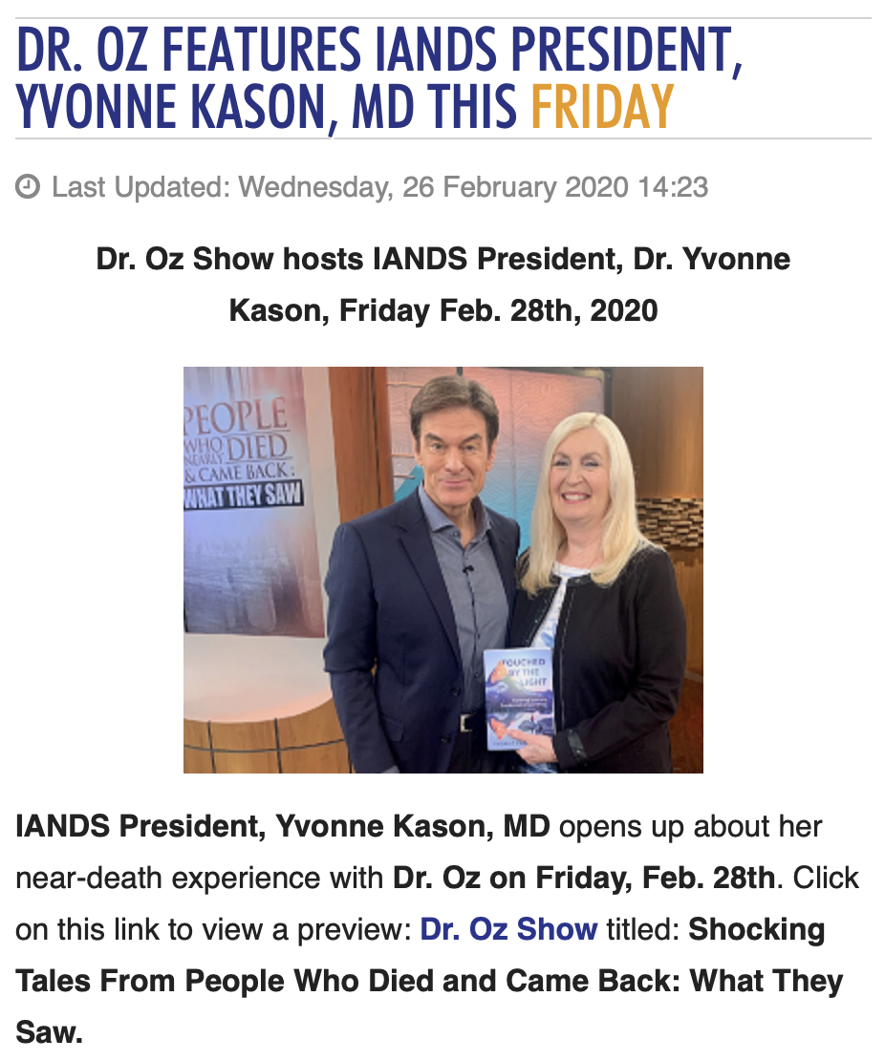

Table 2. An upcoming NDE conference showing possible occult connection
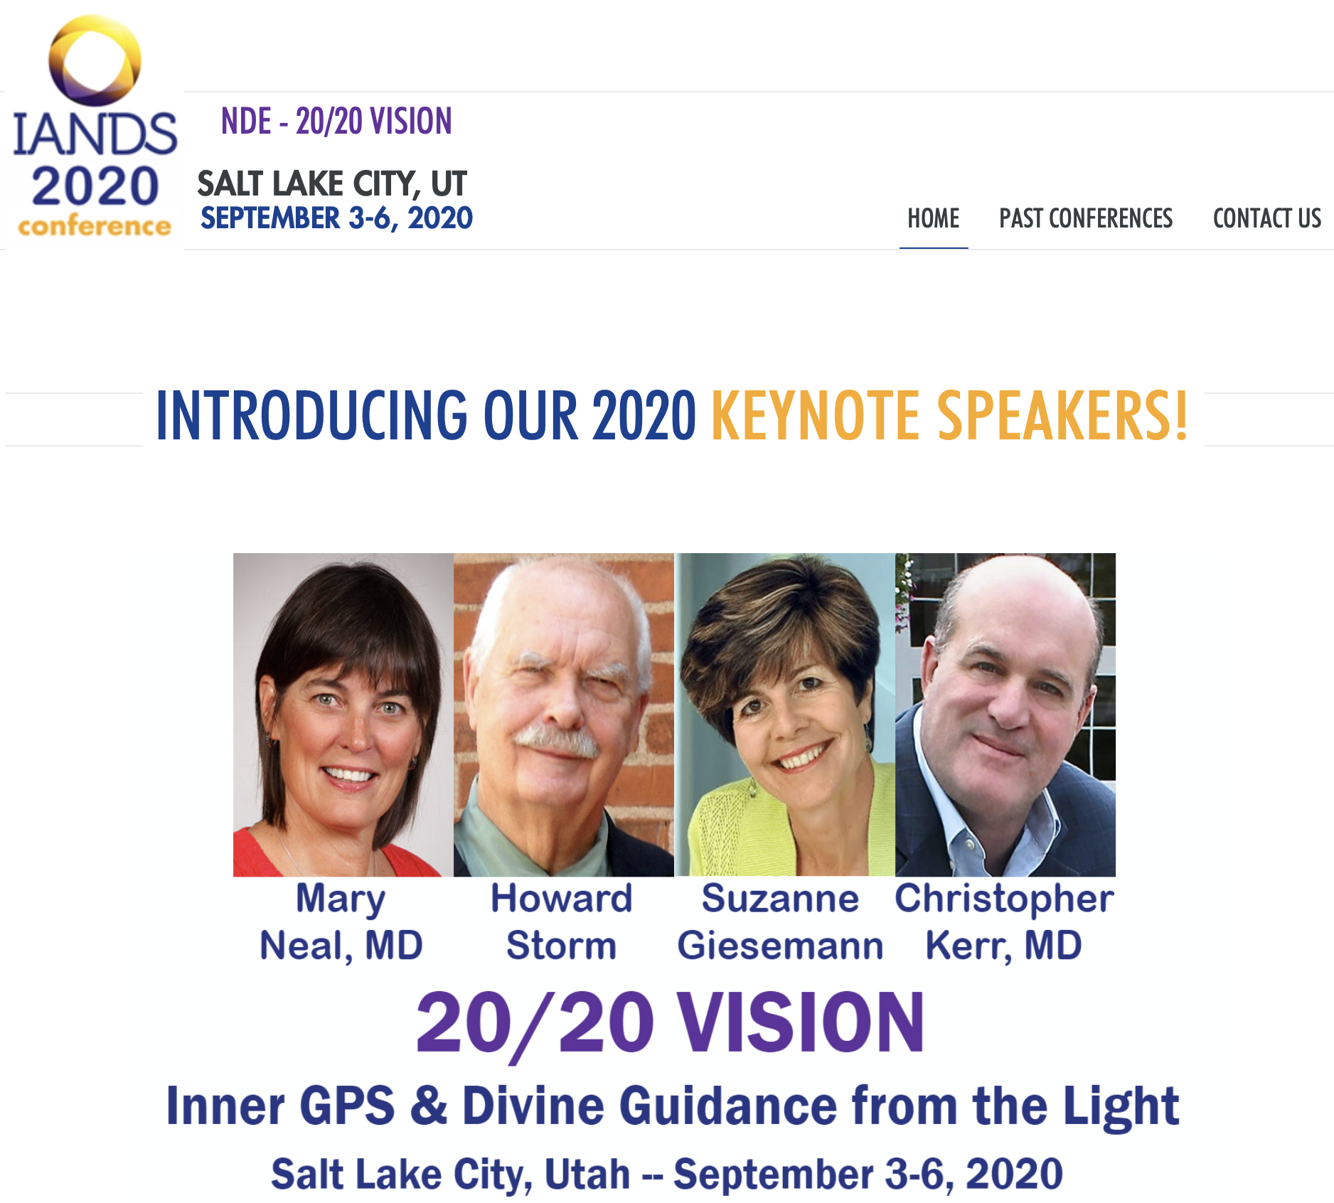
Theological problems. Theology from some NDEs conflict with the Bible. The Bible says Jesus ascended into heaven in a physically resurrected body (Luke 24:39; Acts 1:9-12). But in NDEs, Jesus is often described as a spirit being. For example, one person described Jesus this way: “Reddish-brown hair hung shoulder length on the spirit being, draping around the back of the spirit’s blue T-shirt.” The Bible says nobody can see God’s essence and live (John 1:18). But many NDErs claim to see the person of the Father and even the Holy Spirit. For example, in Heaven is For Real, Colton reports that the Holy Spirit is “kind of blue.” Colton says that, in heaven, “everybody’s got wings” which seems to promote the unbiblical teaching that humans will become angels in heaven. One ‘Jesus’ told an NDEr that there were errors in the Bible and even denied the Bible’s central teaching that humans are sinful. In another encounter, ‘Jesus’ told an NDEr that his mission was to teach love (not be an atoning sacrifice), we should not criticize any religion, that we pre-existed before we were born and that we even volunteered for what we would do on earth. Many see a problem with Hebrew 9:27’s teaching that “it is appointed for man to die once, and after that comes judgment.”
Additional revelation. The author of Imagine Heaven believes NDEs “are a gift from God to color in the picture revealed by the prophets and Jesus.” Here is a sketch of heaven built from common NDE experiences. People have bodies of light which can feel, eat fruit, float, fly at the speed of thought and appear as any age. People have enhanced, telescoping and even 360-degree vision and can communicate via telepathy (mind to mind). People are greeted in heaven by welcoming parties made of close relatives and friends. They talk to Jesus. They are brought to an open field/meadow with lush glowing grass that does not break when stepped on, and trees that immediately bear new fruit when plucked. Off in the distance on a high mountain is the New Jerusalem, the city of God with a beautiful blue wall and pearlescent gate. There are waterfalls that create music, lakes with boats, a river of life where you can breathe under water, a tree of life, children playing, dogs jumping at angelic air shows. It seems that the author anticipates that his book will make Christians uncomfortable, since it is, for all practical purposes, additional revelation that is likely going beyond the Bible. He tries to calm people’s concerns by saying from the start, “I’m not seeking to add content to what the Scriptures already teach, but rather, help you imagine it.” But the NDE stories arguably do seem to add revelatory content to what the Bible says and this makes many Christians uncomfortable.
Demonic deception. Christians are warned in the Bible that everything must be tested against the Word of God. The Apostle John said, “Dear friends, do not believe every spirit, but test the spirits to see whether they are from God, because many false prophets have gone out into the world.” (1 John 4:1) These evil spirits (demons) of the false prophets in John’s day were apparently denying that Jesus came in a real physical body. John writes, “every spirit that does not acknowledge Jesus is not from God. This is the spirit of the antichrist, which you have heard is coming and even now is already in the world.” (1 John 4:3) Therefore, it is very possible that there is demonic deception involved in these NDEs. All Christians (as far as I’m aware of) emphasize the need to compare the teaching of each NDE to what the Bible teaches. Medical doctor and conservative Christian Michael Sabom put it well:
After more than two decades of studying the near-death experience, this is where I end up: The NDE is a powerful spiritual experience which causes dramatic changes in one’s behavior and beliefs. Without the Word of God, we are without a road map to determine good from evil, and Satan and his demons are free to deceive “even the elect” (Matt. 24:24).

What to Make of NDEs? Three Positions
What then should Christians make of NDEs? There is explosive interest in the topic in the past forty years. Prominent theologians are publicly saying there is something to them which cannot be ignored. And Christian apologists are beginning to use NDEs to argue for the truth of Christianity. There seems to be three general positions among Christians.
Position 1: NDEs are mostly genuine. Some Christians think NDEs are genuine glimpses of heaven and/or hell. They are convinced that most NDE details—encounters with God/Jesus, meeting deceased family members, seeing heaven, and so forth—really happened as described. Christians from this camp tend to emphasize the similarities of NDEs and think that the common features speak to truths already revealed in the Bible. They do agree that some NDEs may involve demonic deception and therefore we should evaluate each one according to the Bible. But, in general, these stories mostly strengthen the case for Christianity. They believe we can/should use evidence provided by NDEs in apologetics to convince unbelievers of the reality of the Christian faith. They can also be an encouragement to Christians. John Burke, with his Imagine Heaven book, seems to hold this position.
Position 2: NDEs are mostly ungenuine. Some Christians think NDEs are mostly illegitimate and cannot be relied upon. These Christians emphasize dissimilarities between the stories. For example, Hank Hanegraaff is in this camp. He said, “when you look at the near-death experiences that are being sold in the Christian community and the secular community… all of them have one thing in common. And that is, they don’t have anything in common.” If these experiences are not genuine, how are the stories explained?
Some think they are the result of demonic deception. They feel the evidence for this is that many NDEs have unbiblical theology and tend to point toward universalism/pluralism and greater interest in the occult. “What they are coming back in terms of stories doesn’t correspond with what the Bible says.”
Other Christians, like Michael Sabom, point to a physical explanation. In his view, death is not instantaneous but a process. The physical body, as it is dying, can influence the mind to produce the unbiblical aspects of NDEs. The subject really does leave their body via the soul, but in the process of death, they are still alive. Therefore, their physical mind somehow brings ideas from their worldview into their NDE, which may or may not be biblical.
Position 3: NDEs are minimally helpful to prove the existence of the soul beyond the physical body. There seems to be a third position among apologists. That is, NDEs are not completely reliable. But they are also not completely useless in defending Christianity. They are minimally useful in arguing that the soul does indeed continue beyond death. One prominent apologist, Gary Habermas, seems to hold this position: “While the evidence presented here does not constitute proof or total certainty, it does provide rather strong evidence for life after the death of the body.” It is difficult to ignore confirmed reports of what people observed while outside their bodies. NDEs do provide evidence that the soul still operates beyond clinical death. And this is a good reason for Christians to be at least somewhat familiar with the topic.

My Position
I personally want to believe that some/most Christian NDEs are truly genuine (position 1). As I write this, the world is falling apart with the COVID-19 crisis. I find myself longing for the heaven described by the many so-called NDE visitors—for example, walking with Jesus in an open field wish lush trees and grass, playing in a River of Life, seeing the New Jerusalem high on a hill. It all sounds so breathtaking! Reading many of these NDE stories has been an unexpected source of encouragement to me during this time. But I am also concerned with others about the possible deception. We simply do not know how much our physical dying body interferes with these experiences. Worse, we do know that Satan “masquerades as an angel of light” and is capable of tremendous deception. (2 Cor. 11:14) Therefore, I lean more toward position 3. They are helpful in apologetics to prove the existence of the soul apart from the body, but are likely very subjective, and therefore we should exercise caution and compare each one with Scripture. One thing is sure; there will come a day when we will know for certain whether these experiences are true—when we breathe our last and see the face of our Lord. (2 Cor. 5:8)

Bibliography
Burke, John. Imagine Heaven: Near-Death Experiences, God's Promises, and the Exhilarating Future That Awaits You. Grand Rapids, MI: Baker Books, 2015.
Burpo, Todd. Heaven Is for Real Movie Edition: A Little Boy's Astounding Story of His Trip to Heaven and Back. Nashville, TN: W Publishing Group, 2010.
Conway, Bobby. “241. Afterlife: Near-Death Experiences.” The One Minute Apologist. March 18, 2013. https://oneminuteapologist.com/video/241-afterlife-near-death-experiences/.
Habermas, Gary, and J. P. Moreland. Beyond Death: Exploring the Evidence for Immortality. Eugene, OR: Wipf & Stock Publishers, 2004.
Holden, Janice Miner, Bruce Greyson, and Debbie James. The Handbook of Near-Death Experiences: Thirty Years of Investigation. Santa Barbara, CA: Praeger, 2009.
IANDS. “2020 IANDS Annual Near Death Experience (NDE) Conference: Revolutionary Experiences.” Accessed April 2, 2020. https://conference.iands.org.
———. “Dr. Oz Features IANDS President, Yvonne Kason, MD This Friday.” Last modified February 26, 2020. https://iands.org/1441-dr-oz-features-iands-president-yvonne-kason-md-this-friday.html.
Long, Jeffrey, and Paul Perry. Evidence of the Afterlife: The Science of Near-Death Experiences. New York: HarperOne, 2009.
Moody, Raymond A., and Paul Perry. The Light Beyond. New York: Bantam Books, 1988.
Murphey, Cecil, and Twila Belk. I Believe in Heaven: Real Stories from the Bible, History and Today. Ventura, CA: Gospel Light, 2013.
NDERF, Near-Death Experience Research Foundation. “NDERF Home Page.” Accessed April 2, 2020. https://nderf.org.
Sabom, Michael. Light and Death: One Doctor’s Fascinating Account of Near-Death Experiences. Grand Rapids, MI: Zondervan, 1998.

Gary Habermas and J. P. Moreland, Beyond Death: Exploring the Evidence for Immortality (Eugene, OR: Wipf & Stock Publishers, 2004), 174.
“NDERF Home Page,” NDERF, Near-Death Experience Research Foundation, accessed April 2, 2020, https://nderf.org.
I think it is possible to build a case that NDEs could be categorized under paranormal apologetic, experiential apologetics, and/or evidential apologetics.
Habermas and Moreland, Beyond Death, 156.
Ibid.
Raymond A. Moody and Paul Perry, The Light Beyond (New York: Bantam Books, 1988), 18, 19. Jeffrey Long and Paul Perry, Evidence of the Afterlife: The Science of Near-Death Experiences (New York: HarperOne, 2009), 1-17. Habermas and Moreland, Beyond Death, 155. Cecil Murphey and Twila Belk, I Believe in Heaven: Real Stories from the Bible, History and Today (Ventura, CA: Gospel Light, 2013), 275-279.
Janice Miner Holden, Bruce Greyson, and Debbie James, The Handbook of Near-Death Experiences: Thirty Years of Investigation (Santa Barbara, CA: Praeger, 2009), 70 in John Burke, Imagine Heaven: Near-Death Experiences, God's Promises, and the Exhilarating Future That Awaits You (Grand Rapids, MI: Baker Books, 2015), 222.
Burke, Imagine Heaven, 222.
Ibid., 222-228.
Burke, Imagine Heaven, 227.
Ibid., 228.
Wikipedia, s.v. “Near-Death Experience,” https://en.m.wikipedia.org/wiki/Near-death_experience.
Habermas and Moreland, Beyond Death, 159.
Burke, Imagine Heaven, 24.
Habermas and Moreland, Beyond Death, 159.
Ibid., 161.
Ibid., 160.
Michael Sabom, Light and Death: One Doctor’s Fascinating Account of Near-Death Experiences (Grand Rapids, MI: Zondervan, 1998), Kindle loc. 2803-2814.
Ibid., Kindle loc. 2918-2919.
Burke, Imagine Heaven, 42.
Ibid., 45.
Habermas and Moreland, Beyond Death, 213.
Ibid., 215.
Burke, Imagine Heaven, 31, 32.
Ibid., 36.
Habermas and Moreland, Beyond Death, 163.
Ibid., 173, 174.
Holden, Greyson, and James, The Handbook of Near-Death Experiences, 7.
Wikipedia, s.v. “Near-Death Experience,” https://en.m.wikipedia.org/wiki/Near-death_experience.
Sabom, Light and Death, Kindle loc. 57-61.
Ibid., 2968-2972.
Burke, Imagine Heaven, 2.
Ibid., 28.
“Heaven Is for Real Evangelism Pamphlet,” Navigators, accessed April 2, 2020, https://navresources.ca/product_details.php?item_id=4792.
See Habermas and Moreland, Beyond Death.
Habermas and Moreland, Beyond Death, 178.
Holden, Greyson, and James, The Handbook of Near-Death Experiences, 182.
Sabom, Light and Death, Kindle loc. 2183-2185.
“Dr. Oz Features IANDS President, Yvonne Kason, MD This Friday,” IANDS, International Association for Near Death Studies, last modified February 26, 2020, https://iands.org/1441-dr-oz-features-iands-president-yvonne-kason-md-this-friday.html.
Ibid.
“2020 IANDS Annual Near Death Experience (NDE) Conference: Revolutionary Experiences,” IANDS, International Association for Near Death Studies, accessed April 2, 2020, https://conference.iands.org.
Sabom, Light and Death, Kindle loc. 211-213, emphasis mine.
Todd Burpo, Heaven Is for Real Movie Edition: A Little Boy's Astounding Story of His Trip to Heaven and Back (Nashville, TN: W Publishing Group, 2010), 103.
Ibid., 72.
Sabom, Light and Death, Kindle loc. 3374-3378.
Ibid., 3383-3388.
There is a strong counter argument for this in Murphey and Belk, I Believe in Heaven, 265-270.
Burke, Imagine Heaven, 27, 28.
Burke, Imagine Heaven, 28.
Sabom, Light and Death, Kindle loc. 3480-3483.
Bobby Conway, “241. Afterlife: Near-Death Experiences,” The One Minute Apologist, March 18, 2013, https://oneminuteapologist.com/video/241-afterlife-near-death-experiences/.
Ibid.
Sabom, Light and Death, Kindle loc. 3135-3137.
Habermas and Moreland, Beyond Death, 196.

