Important SAFETY rails in the Creation Debate
___________________

A Paper
Presented to
Thomas Baker
Veritas International University

___________________

In Partial Fulfillment
of the Requirements for the Course
Advanced Scientific Apologetics (AP 902)

___________________

by
Shawn Nelson
December 2018
Important SAFETY rails in the Creation Debate

The Need for Safety Rails
High above the Cheat River in West Virginia is Coopers Rock. Situated atop an abundant outgrowth of green forestry, this large granite rock provides a dizzying overlook far and wide of the unspoiled Appalachian Mountains. Visitors come from all around to take in the gorgeous West Virginia scenery. They are free to move around the face of the large rock; however, they must be sure to stay inside the area marked off by safety rails. These guard rails were put in place to protect viewers from accidentally stumbling down the face of the rock and hurting themselves in the valley below—or worse—plummeting to their death. Visitors are free to move around within these guardrails. But the moment they climb over the rails to go beyond, they risk serious injury.
This is a paper on the creation debate within Christianity—an area in which there is freedom to move around. However, like Coopers Rock, it is an area not without safety rails. If one ventures beyond these rails, they will likely find themselves in theologically dangerous situations. The three major views of creation will be looked at first. Then seven safety rails will be given. Lastly, each of the three views will be evaluated on how well they sit within those safety rails.

Three Christian Views of Creation
There are three major views of creation in Christianity.
(A) Young Earth View. First, there’s the Young Earth position. This view holds that God created the entire universe in six twenty-four-hour days about six-thousand years ago. Life was created at the start in “kinds,” or distinct, fully-functioning lifeforms. Adam and Eve were the first human kind and there was no physical death for humans before the Fall (physical death being a consequence of the Fall). All the events of Genesis (most notably chapters 1-11) are considered real historical events, which involve real people in real places. The Genesis Flood is a very important event (Gen. 6-10) because a global flood (catastrophism) is how fossil evidence is typically explained in a young earth framework. Proponents of the Young Earth view claim to be the most faithful to Scripture. And they allege that any other interpretation besides a plain, normal or “literal” interpretation of the days of Genesis is a direct attack on Scripture.
(B) Old Earth, Non-Evolution View. Next is the Old Earth, Non-Evolution position. People in this camp also believe the events in Genesis 1-11 are real historical events involving real places and people. Like Young Earthers, they also believe life was created in distinct kinds (it did not evolve). But unlike Young Earthers, this view agrees with the majority of the scientific community that universe is 13.8 billion years old (earth being 4.5 billion years old). This long span of time suggests there might be other ways to understand the days of Genesis instead of taking them to mean twenty-four-hour days. They believe that it is possible to hold any of these views while still being entirely faithful to the biblical text. These options are shown in Illustration 1 and can be explained as follows: (1) The creation days were ages or long periods of time (Day-Age View). (2) God took a single week to reveal creation events to Adam, but the act took much longer (Revelatory-Day View). (3) The mention of “evening and morning” could have been just a literary technique not meant to be taken strictly (Literary-Framework View). (4) The creative acts were done in single twenty-four-hour days with long gaps of time between creative acts (Alternate-Day-Age View). (5) There could have been a long gap of time between Gen. 1:1 and 1:2 and/or between 1:2 and 1:3 (Gap Theories). Finally, (6) God could have created the universe with the appearance of age (Ideal-Time View). The 24-Hour Day View (7) is included for comparison.

Illustration 1 – Common Views for “Day” in Genesis 1.
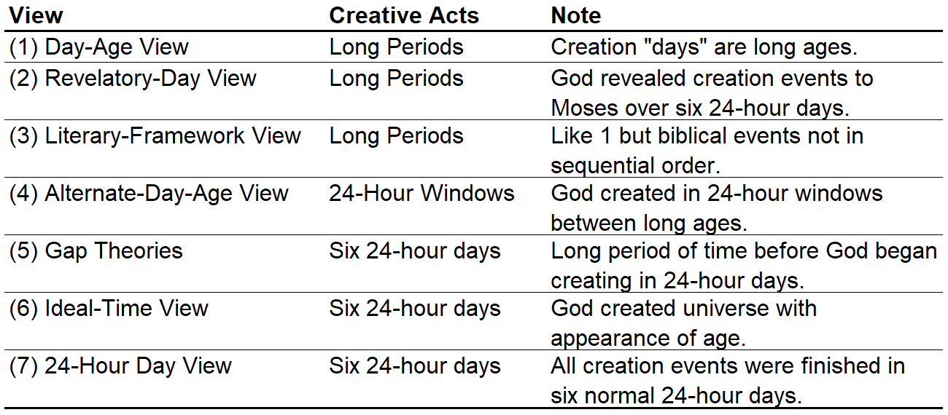
(C) Old Earth, Theistic Evolution View. This view holds that “God created the universe, earth, and life over billions of years, and that the gradual process of evolution was crafted and governed by God to create the diversity of all life on earth.” Natural selection and other evolutionary mechanisms have been acting over long time periods of time to bring about gradual speciation of new life forms. It is virtually the same as Darwinian evolution except that they believe that God guided the evolutionary process (hence the name theistic evolution).
There are two other concepts that are important to understand.
Naturalistic Evolution. Naturalistic evolution stands in contrast to theistic evolution in that it holds that there is either no God at all (atheism) or that God created the universe but is no longer involved in the universe (deism). Since Christianity requires theism, Naturalistic Evolution is not a fitting view for Christians and is only included in parts of this paper for comparison to theistic evolution.
Intelligent Design. There is some confusion today among Christians as to where Intelligent Design fits in the creation debate. This is not a fourth view but is rather a way for arguing for an intelligent designer from the evidence of complexity within nature, especially in the area of biology. Intelligent Design is compatible with all three Christian views above (but not naturalistic evolution which, again, is not fitting for Christians). Another important point is that Intelligent Design tries to remain unfettered to Christianity, so it can appeal to people of different faiths.

What This Paper Attempts to Do
The basic thesis of this paper is that Christians can hold any one of the three views above and still be a bonafide Christian. However, not each view rests on the same footing. Each of the views come with presuppositions. Can we identify a set of assumptions that are biblically and rationally sound, that prevent us from wandering into danger? If so, these can serve as our safety rails. The result is that we can mark off an area where it is safe for Christians to move within this debate, without it jeopardizing some other key area of theology. I think seven key points can be identified that will keep us healthy and on the right track. These are good safety rails for deciding on a view of creation.

Rail One: It’s Important to Recognize the Need for Charity
The first safety rail in approaching the topic of creation is that we should have charity towards those who disagree with our position. All agree in principle that there’s a difference between doctrines that are required for salvation and those that are not. No major leader in this debate (as far as I’m aware of) believes a person’s salvation depends on holding one view over the other. Topics like the trinity, salvation by faith alone, Christ’s substitutionary atonement, the virgin birth, sinlessness of Christ, Christ’s death, burial, resurrection, ascension and future bodily return are primary issues which deserve a more rigid demarcation with dissenters. But all seem to agree that the topic of creation falls under the category of secondary issues because one has freedom to hold any of the three views, and still be saved. That’s not to say it is not important. It is extremely important because one’s view of creation involves a set of assumptions that affect other doctrines (the point of this paper). But regardless, it is a secondary issue.
If we cannot learn to get along with other Christians in the church who have different views than us on these secondary issues, we are going to run into some serious challenges. It is mind-boggling how many ways there are to disagree with other Christians. Illustration 2 shows some commonly debated topics. This list simply focuses on things that people in a typical conservative church in America today might disagree about. It deals with theological and ethical issues only. It leaves out topics conservatives usually agree on like their stance against homosexuality and transgender rights. And it avoids practical topics of disagreement seeker-friendly vs. believer-based sermons, contemporary vs. traditional worship, etc. It is clearly not exhaustive. Yet, amazingly, there are 97,387,593,162,817,536 ways to hold that list of options. This means that the odds of me finding somebody who agrees on every point as I do on that list is a whopping one in 97 quadrillion!

Illustration 2 – Commonly Debated Topics Among Conservative Christians.
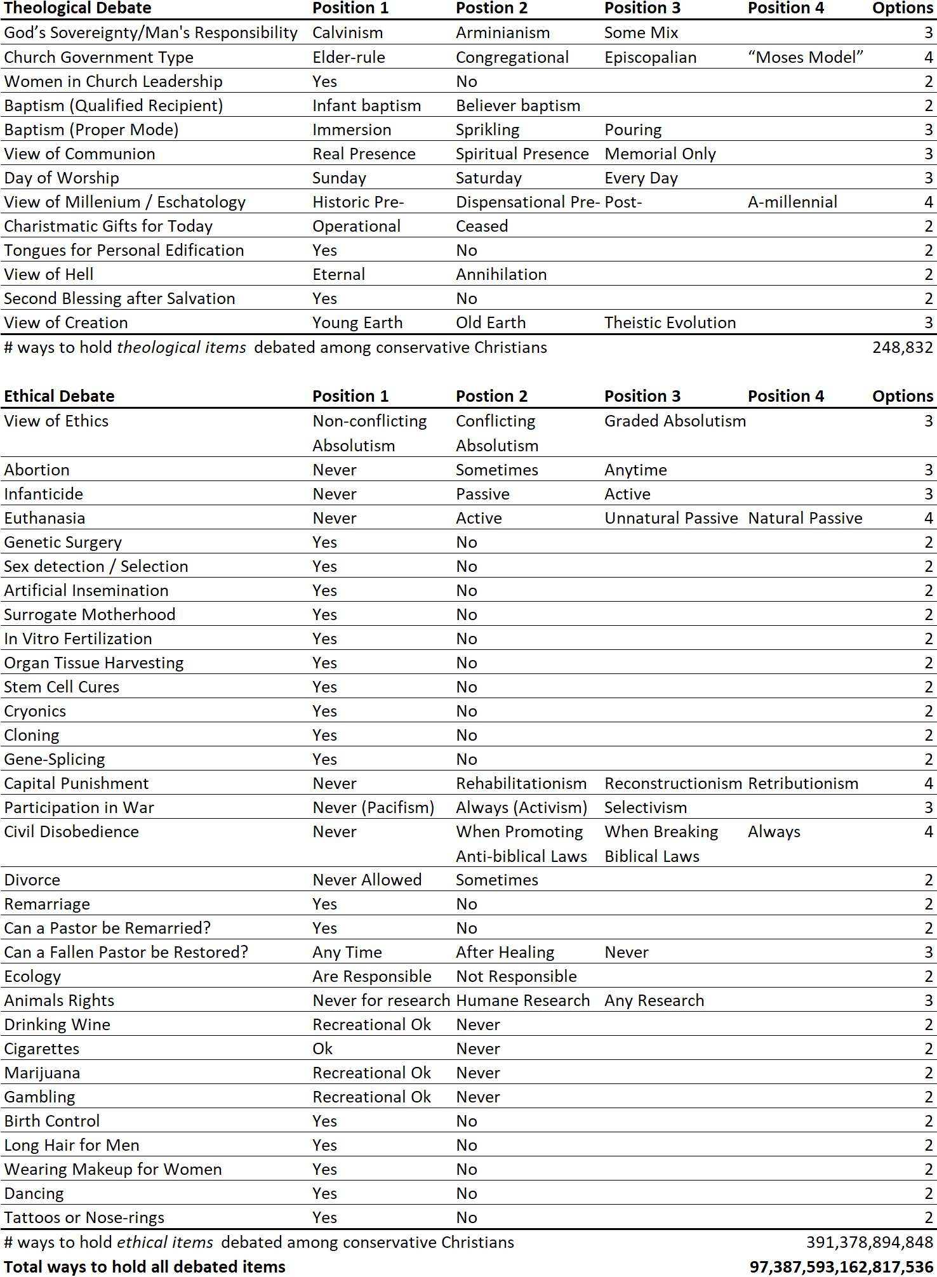

Most Christians simply aren’t aware of how much disagreement there is around them—hence the need for grace in these “gray areas” (Rom. 14). I’m convinced most churchgoers in my denomination (Calvary Chapel) would be shocked to hear that many giants of the faith like C. S. Lewis, Billy Graham, Tim Keller, John Stott and Alister McGrath believe/believed in evolution. Then there are those who changed their position: Norm Geisler is a Young Earther who became an Old Earther; R.C. Sproul was an Older Earther who became a Young Earther. Are these heretics? Certainly not! If and when we levy pejorative attacks against other Christians or defame their character because they hold a different view, I believe we have climbed over the safety rail established by Scripture. Not only do we do injury to others, but we risk injury to ourselves. There is a warning of loss of rewards (Mt. 12:46). There are also fewer ministry opportunities after being rightly labeled a sour Christian who cannot “play well in the sandbox” with other Christians. Extreme dogmatism might work in a smaller congregation where people are already aligned to one view of creation. But in a larger congregation with representatives of other views, charity is needed. So, at the start, it is important to have charity and gentleness towards our brothers and sisters who have different views from our own.

Rail Two: It’s Important to Value the Bible as Special Revelation
The next safety rail in this debate is that we should champion a high-view of the Bible. When in doubt, err on the side of the reliability of Scripture. Instead of treating the Bible as guilty unless proven innocent, treat it as innocent until proven guilty. As Christians, we believe that God has spoken to mankind and given us more information about reality than what we could know through science alone. We call this revelation the Bible. Therefore, any view of creation should value the Bible as an authoritative and reliable means of divine revelation.
Not all have the same view. That we should value the Bible as Christians should be a given. But the problem is not all value it to the same degree in this debate. A look at the three “in”s of Scripture helps make this clear. When talking about Scripture, the terms inspiration, infallibility and inerrancy are used. Inspiration is the belief that the Bible comes from God (it is breathed out by God; 2 Tim. 3:16-17). Infallibility says that the Bible cannot fail (not one jot or tittle will disappear until all is fulfilled; Matt. 5:18). And inerrancy holds that the Bible is without error. The key to understanding difference of opinions in this debate surround the last of these: inerrancy. Full inerrantists believe the Bible is without error in everything it speaks about (including science and history). People holding this view are said to have a high-view of Scripture. Limited inerrantists, on the other hand, say the Bible is accurate when it speaks about things pertaining to salvation, but not necessarily when speaking about things of history or science.
Compromising with full inerrancy is dangerous. Climbing over the safety rail of a high-view of Scripture (full inerrancy) is dangerous for four reasons. First, full inerrancy is based on the character of God who cannot lie (Heb. 6:18; Titus 1:2). Therefore, an attack on the Bible (God’s Word) is an attack on the character of God Himself. Second, we should have the same view of the Bible as Jesus and the New Testament writers. Christ and the New Testament writers use of Old Testament Scriptures shows a belief in its total truthfulness. Jesus and his apostles affirmed the fact of creation (Jn. 1:3), Adam and Eve as real people (1 Tim. 2:13-14), the Fall of mankind in the Garden (1 Tim. 2:14; Rom. 5:12; 1 Cor. 15:22), Cain murdering his brother Abel (1 Jn. 3:12), Noah and the Flood (Luke 17:27; Mt. 24:39; 2 Pet. 2:5), the genealogical line of Shem one of Noah’s sons (Lk. 3:35-36), the historicity of Abraham (Luke 3:34; Heb. 7:1-3; 11:8), the destruction of Sodom and Gomorrah (Luke 17:29), the calling of Moses and events of the Exodus (Luke 20:32; 1 Cor. 10:1-2; 3-5; Jn. 3:14; Heb. 11:30), Jericho’s destruction (Heb. 11:30), and even Jonah in the large fish (Matt. 12:40) and Daniel in the Lion’s den (Heb. 11:33). Third, inerrancy has been the historic position of the church. It is only until about one-hundred and fifty years ago that Christians began to question this doctrine. Fourth, inerrancy is the epistemological foundation of all other Christian doctrines. The authority of every other Christian teaching rests on the divinely authoritative Word of God. Because of this, inerrancy is “the fundamental of all the fundamentals.” If the epistemological foundation falls, so too falls every other doctrine. If the epistemological foundation is questioned, so too is every doctrine questioned.
Therefore, any attempt in the creation debate to dehistoricize biblical people, places and events is extremely dangerous. One cannot climb over this guard rail without risking injury to themselves or others.

Rail Three: It’s Important to Value Science as General Revelation
The next safety rail is that Christians should value science.
Compatibility of science and Christianity. Contrary to what some people might think, there is no war between science proper and Christianity. In fact, modern science was hatched in the incubator of the Christian worldview. “The type of thinking known today as scientific, with its emphasis upon experiment and mathematical formulation, arose in one culture—Western Europe—and in no other.” Why is this so? Because the Bible teaches physical creation is real and operates in an orderly way based on natural laws established by a rational God. Since God is trustworthy and dependable, creation too, was understood to be trustworthy and dependable. Since mankind is created in God’s image, he is a rational creature and capable of understanding the order found in the world. Thus, science was viewed as something possible because of the Christian worldview. With this understanding it comes as no surprise that the first scientists were often devout believers who were motivated by the love of science and love of God.
The earlier scientist was very likely to be a believer who did not think scientific inquiry and religious devotion incompatible. On the contrary, his motivation for studying the wonders of nature was a religious impulse to glorify the God who had created them.
Francis Bacon (1561-1626) is known for his inductive methodology which formed the very basis of the scientific method. He was also a devout Christian. Some of the first astronomers and pioneers of the scientific revolution include Nicolaus Copernicus (1473-1543), Johannes Kepler (1571-1630) and Galileo Galilei (1564-1642). These were all professing believers in God and the Bible. Isaac Newton (1643-1727) is credited as one of the most influential scientists of all time. Newton wanted his scientific work to be used for apologetics. The first modern chemist, Robert Boyle (1627-1691) was also a Christian, as were the first botanists, John Ray (1627-1705) and Carl Linnaeus (1707-1778). Michael Faraday (1791-1867) was a Christian who pioneered the study of electromagnetism. Gregor Mendel (1822-1884) was a Christian who founded genetics. Louis Pasteur (1822-1895) was a Christian biologist and chemist who is known for his breakthroughs with vaccinations.
Science as a means of discovery. God created us to be creatures who can know reality by what we observe. In the creation account, it says God brought the animals to Adam in order that he should observe and name them (Gen. 2:19-20). It was during this process of identifying similarities and differences (i.e., genus and species) between animals in nature that Adam realized there was nobody else like himself (another human). The names that Adam gave to each creature God brought to him was an expression of its essential nature, “a task involving detailed observation, description, and classification. Thus, Genesis appeared to give divine justification to the study and analysis of the natural world.” Mankind’s study of the natural world is also implied in our God-given mandate to take dominion of the natural world (Gen. 1:28). Our ability to know truth about reality from general revelation is so effective that it actually becomes the basis for mankind’s universal judgment (Rom. 1:20; 2:15).
Science as a means of biblical clarification. Reason and observation can also help clarify Scripture. Point five will cover ambiguity involved in communication in more detail. But simply put, science can help clarify a biblical author’s intended meaning. For example, there was a time when people thought Joshua 10:12-14 taught the sun revolves around the earth (because it was said to stand still). However, science has now shown the earth revolves around the sun, so there must be some other way to understand Joshua 10. Revelation 7:1 mentions the “four corners” of the earth. Taken at face value, this could lead some to argue that the earth was a square. However, science has shown the earth is a sphere. There must be some other way to understand this passage as well. The Bible also says that at the coming of Messiah hills will sing and trees will clap their hands (Isa. 55:12). We know from observation that hills do not sing, and trees do not have hands for clapping, so again, this must mean something else. I do not know any Christian who believes the sun revolves around a square earth that has trees with hands. This is because they have allowed science to help clarify these passages (they are either metaphors or phenomenological descriptions).
Therefore, valuing science is an important safety rail. If we climb over it, we may lose touch with reality and can find ourselves at risk of misunderstanding God’s intended meaning in Scripture.

Rail Four: It’s Important to Acknowledge the Limitations of Science
The previous point argued we should value science as a means of discovery and as an aid to biblical clarification. However, science is not without limitations. Our next safety rail is that we should acknowledge these limitations.
Scientists play an active role. Some people think “science” is an unbiased methodology. However, “Everyday observation is far from passive.” All scientists begin their study of “the facts” inside a given philosophical worldview. This worldview helps guide the entire process: it helps determine which facts are sought, how experiments are conducted, and even how resulting data is assimilated. Instruments by themselves do not measure; “ultimately, they require a mind.” Observation is more than just static “images cast upon the retinas” but is assimilated by a human mind that has been shaped by “experience, knowledge and expectations of the observer.” Thus, the scientist is not neutral in the process but plays an active role in shaping the data. Therefore, there is an inescapable problem of bias in science.
Problem of induction. There’s also the problem of uncertainty. We can never prove something with absolute certainty unless we have all relevant subjects in our reach of study. But since we never know if we have all relevant subjects, how can we be sure of our results? Any conclusion we make will “invariably go beyond the finite amount of observable evidence that is available to support them, and that is why they can never be proven in the sense of being logically deduced from that evidence.” Therefore, ultimately science cannot tell us what is certain but only what is probable. Science (induction) therefore is “fallible, ever subject to revision, and always characterized as ‘probable’ in varying degrees.”
These problems are so real that people have had to figure out ways for science to progress despite these serious limitations. Three significant people have proposed solutions.
Karl Popper. Karl Popper (1902-1994) introduced falsificationism as an alternative to induction. Popper argued that while we cannot derive general scientific laws from a finite set of observable facts, we can prove something is wrong: “The falsity of a law can be logically deduced from a single observable fact with which it clashes.” Any theory that is not able to be falsified is not meaningful. Theories that are more falsifiable than others are to be preferred over less falsifiable ones. A strong theory is one that is highly falsifiable, yet is not falsified. Thus, Popper found a clever way for science to progress, despite the real limitations of induction.
Thomas Kuhn. Thomas Kuhn (1922-1996) examined the issue of bias. He understood that scientists operate within frameworks—to the point where he saw the entire history of science as movements through paradigm shifts. He argued that the history of science has and will continue to progress through several identifiable stages: (1) pre-science; (2) normal science; (3) crisis; (4) revolution; (5) new normal science; (6) new crisis; etc., to infinity. What a population calls “normal science” is really just the currently accepted paradigm of the majority. Inevitably, as the history of science shows, there arises an anomaly that is not consistent within the currently accepted paradigm. When enough anomalies are discovered, there’s a period of insecurity. Scientists who veer away from the accepted paradigm appear to be “living in different worlds.” At some point when the anomalies cannot be ignored any longer, there is a crisis leading to a revolution, during which the new paradigm becomes the accepted norm. In this way, for Kuhn, scientific revolutions are like political revolutions, gestalt switches and even religious conversions. Scientific revolutions include (1) moving from Euclidean to Non-Euclidean geometry; (2) from an Aristotelian/Ptolemaic model of the universe to that of Copernicus; (3) from Newton’s concept of gravity to Einstein’s; and (4) from the Standard Model of physics to Quantum Mechanics.
Imre Lakatos. Imre Lakatos (1922-1974) tackled bias head-on by sanctioning the ability to ignore it for a reasonable amount of time. He agreed with Kuhn that scientists operate inside paradigms and like Kuhn, he felt that scientists should be allowed freedom to work within a paradigm without worrying about whether their paradigm was literally true. He coined the phrase “research program” to formalize this thought. The idea behind a research program is that scientists should be allowed freedom to properly develop a hypothesis. The hypothesis is considered the “hard core” of a program. Additional hypothesis that supplement the hard core become the “protective belt” of the program. “Scientists are advised not to tinker with the hard core of the program in which they work. If a scientist does modify the hard core then he or she has, in effect, opted out of the program.” Lakatos believed that each research program must be given adequate time to realize its potential. But while the program is underway, the hard core is effectively rendered unfalsifiable by scientists within the program. In this way, science can progress, despite the problem of uncertainty.
It should be clear from this short summary that science is not without bias and limitations. If there seems to be a passage that conflicts with a currently accepted scientific paradigm, it could be that the problem is with the scientific model and not the Bible. The Christian should acknowledge that science is not infallible and put science in its proper place. This safety rail can give some a much-needed reality check.

Rail Five: It’s Important to Acknowledge a Difference
Between the “Word of God” and Interpretation
The fifth safety rail regards another limitation: this time the limitation is with communication. In short, there’s a difference between the “Word of God” and my interpretation of the Word of God. “Inerrancy simply affirms that whatever the Bible affirms is true, but only hermeneutics can inform us as to what the Bible is actually affirming.” The following chart presents this difference, with explanation following:

Illustration 3 – The Biblical Text vs. What the Bible is Affirming.
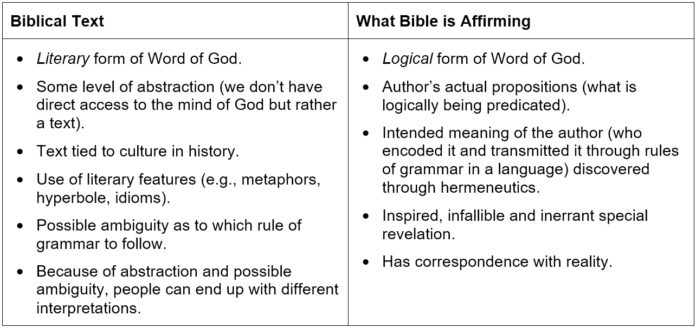
Encoding/decoding process. All communication involves an encoding and decoding process. It begins with the sender of a message (the author). The sender instantiates the idea of a particular thing from reality as a universal idea in their mind. Predications are made of these ideas which involve the use of grammar. This grammar is tied to a particular language and culture. This grammar serves as a way of protecting the meaning of the message so that the original meaning of the message is preserved. This message is distributed either by way of sound waves or written text. The mind of the hearer/reader receives the words and using the same rules of grammar of the sender (based on the culture and language), unpacks the meaning to understand the author’s predications that are being made. The receiver correctly understands the sender’s meaning to the degree that they have correctly followed the same rules of grammar and language as the sender.
Bible as communication. The Bible follows this same encoding/decoding process. When we say that the Bible is the “Word of God,” what we are saying is that it is communication from God to man. But Christians do not have direct access to the mind of God to receive this divine communication. Instead, the message has been encoded the same way it is encoded in all communication: in grammar and the rules of language. Our goal, if we want to understand the author’s meaning (in this case, God’s), is to determine the meaning by the grammar of the biblical text. However, because it is not always clear about which rules the sender has applied, there can be some level of ambiguity, and therefore uncertainty when trying to understand the author’s intended meaning.
Judgment calls with grammar. Meaning is tied to grammar and the rules of grammar are tied to a language of a particular people in culture and in time. The goal of the grammatical-historical method of interpretation in hermeneutics is to ultimately determine the author’s intended meaning by taking all these things into consideration. But as every student of Greek and Hebrew knows, even if a person knows the rules of grammar and language well, judgment calls must still be made because sometimes there are options concerning which rule to apply. We also need to take things into consideration like idioms, figures of speech, hyperbole, metaphor, etc. Sometimes it is not entirely clear when these are being used.
Judgment calls with logical form (predication). There is another level of abstraction found in Illustration 3. People (including the biblical writers) do not write in logical form. But for us to understand something logically it needs to be changed from its literary form to its logical form. If the Bible were given by God in syllogistic form, we would have much less to argue about. However, since it was not, we must translate from literary to logical form. This, too, requires making judgment calls.
Degrees of probability. The point of the above is that there can be a difference between the “Word of God” and my interpretation of the Word of God. The degree of separation depends on how far off I am from the grammar (or use of idioms, metaphors, hyperbole, etc.) used by the author when they encoded their message. Because of ambiguity, there is some level of uncertainty. Can we ever be sure that we have applied the exact same rules of grammar as the sender to properly understand the message? If we are honest, we can only be certain to some degree of probability. This is not saying that all doctrines are uncertain but not all doctrines are as certain as others (e.g., the secondary ones like creation); hence need for charity (Rom. 14).
When it goes too far. Because of inherent ambiguity and uncertainty in communication, there is some freedom of interpretation in secondary areas. However, this is clearly not a license to distort the text beyond what the rules of grammar allow (i.e., eisegesis). The International Council on Biblical Inerrancy said that attempts to dehistoricize people or events that Jesus and the NT biblical writers considered were real events has gone too far—they have effectively climbed over an important safety rail.
With regard to the historicity of the Bible, Article XIII in the commentary points out that we should not “take Adam to be a myth, whereas in Scripture he is presented as a real person.” Likewise, it affirms that we should not “take Jonah to be an allegory when he is presented as a historical person and [is] so referred to by Christ.”
Furthermore, the Chicago Statement on Biblical Inerrancy says, “We affirm that Genesis 1-11 is factual, as is the rest of the book.” It rejected any attempt to dehistoricize the creation account. Therefore, any creation view which attempts to dehistoricize the creation account or the historicity of Adam and Eve has gone too far and should be avoided.

Rail Six: It’s Important to Affirm Teleology
Another important safety rail is that we recognize God as an intentional Creator, who created distinct things that operate towards an end that He determined. All creators (artists, architects, computer programmers, etc.) begin with ideas in the mind that are ordered to some desired end (teleos). These ideas are then brought into existence in some way by acting upon them in reality. In a similar way, God is a Creator. All Christians in this debate believe in creation ex nihilo (out of nothing). This means that before the creation event, the universe did not exist but everything “existed” only as ideas in the mind of God. God as Creator brought these ideas into being by giving them existence. In philosophical terms, we say that things in this created world are composed of matter and form (called hylomorphism; hlyo means matter and morph means form). In other words, things are not just matter but form (God’s idea) as well.
A real world of distinct things. That everything in the universe is not just matter but idea/matter is significant. It means that there are distinct things existing in the world. “There is a real world, and that the things in it are all real in the sense that they are beings of one kind or another and their being is not a matter of opinion or conjecture.” When God created everything in nature, he endowed each thing with a nature (essence). A thing’s essence is its identity. A thing’s identity is known by looking for similarities and differences (genera and species). Without identity we could not rightly divide and define the natural order (taxonomy) and we could not do science. “We could not describe something as growing, aging, or decaying unless there was some identity that survived through the change.” Things are more than just a set of elements or atoms. Things really do exist by virtue of God bringing ideas (form) into being (matter) and they really do have a real essence, substance and identity.
Teleology. These matter/ideas are not only distinct essences, but everything operates towards an end that God determined (teleos). In other words, things do not happen haphazardly in God’s created order, but they happen intentionally. When God created things, He created them to function within an order. Thus, they are directed towards an end and gave a purpose (they have final causality). All substances in creation evidence patterns of teleology, but this is especially evident within biological systems: “When we reach the level of biological systems, such as plants, animals, and humans, we see a profound complexity that cannot be explained by just the sheer collisions of atoms and their covalent and ionic bonds through the mediating fundamental forces.” Teleology is also known as specified complexity and irreducible complexity.
In conclusion, any Christian who flirts with a cosmogony that rests on purely a naturalistic or material causes has climbed over an important safety rail. A good Christian view of creation recognizes God as Creator, who created distinct things that operate toward an intentional end.

Rail Seven: It’s Important to Acknowledge a Difference
Between Primary and Secondary Causes
The last safety rail is directed towards those who might try to label theistic evolutionists as godless heretics. Theistic evolution is based on the idea that God is a primary cause who used evolution as the secondary cause for the origin of all things. In this belief, God has either been guiding evolution through natural processes or He has endowed a kind of limited self-assembling ability to things within creation. God is actively involved as the primary cause, ensuring that things reach the end He determined (teleos) by means of secondary causes. See Illustration 4. Logically speaking, if God has used cosmic, chemical and biological evolution to create life, then He would still justifiably be called the Creator. In this case, God would be the remote Cause, while forces within nature would be the proximate cause. However, I do find great difficulty with this view considering the items above. To me, it seems there is no way to embrace evolution without destroying identity. Yet, understanding how a theistic evolutionist looks to God as Creator really does help me understand where they are coming from, and helps me have charity. For this reason, it is briefly mentioned.

Illustration 4 – Primary Causes vs. Secondary Causes
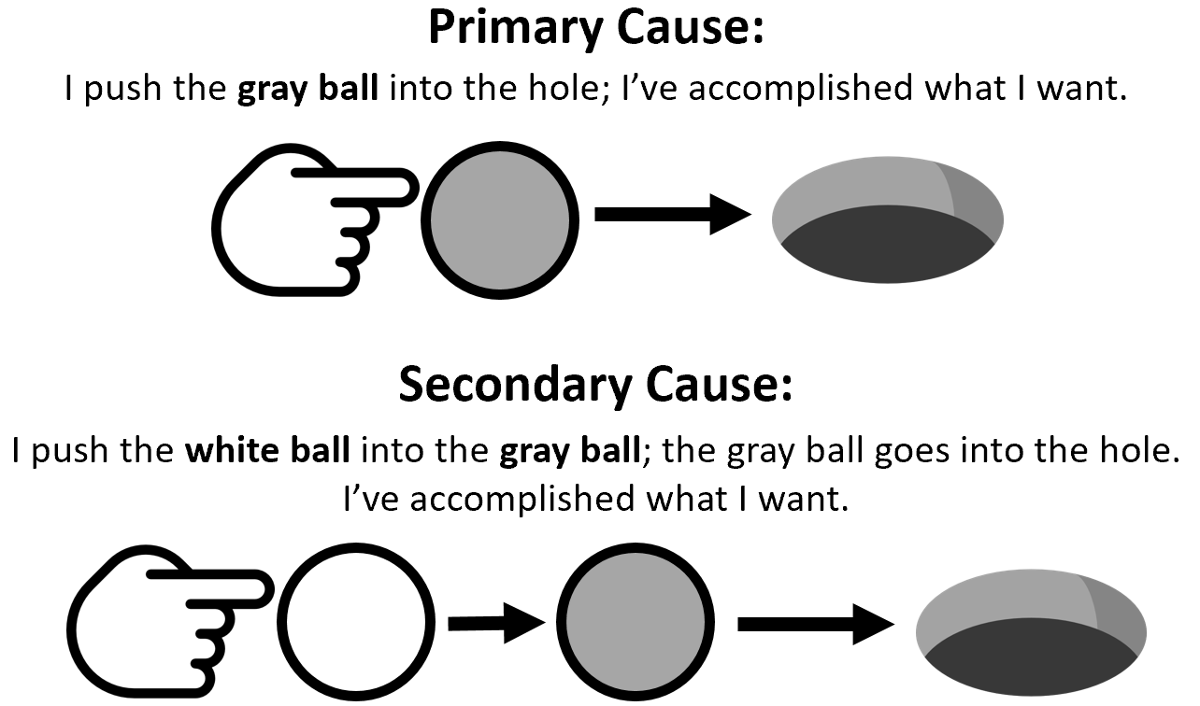

A Complete List of Safety Rails
Summarizing all points above, here are the safety rails I suggest for those in the creation debate. It is important that we: (1) recognize the need for charity; (2) value the Bible as special revelation; (3) value science as general revelation; (4) acknowledge the limitations of science; (5) acknowledge a difference between the “Word of God” and interpretation; (6) affirm teleology; and (7) acknowledge a difference between primary and secondary causes. By staying within these safety rails, a Christian protects themselves from hurting themselves and others. Each of the views of creation will now be evaluated with these in mind.

Illustration 5: Evaluation of How Each View of Creation Sits within the Safety Rails.
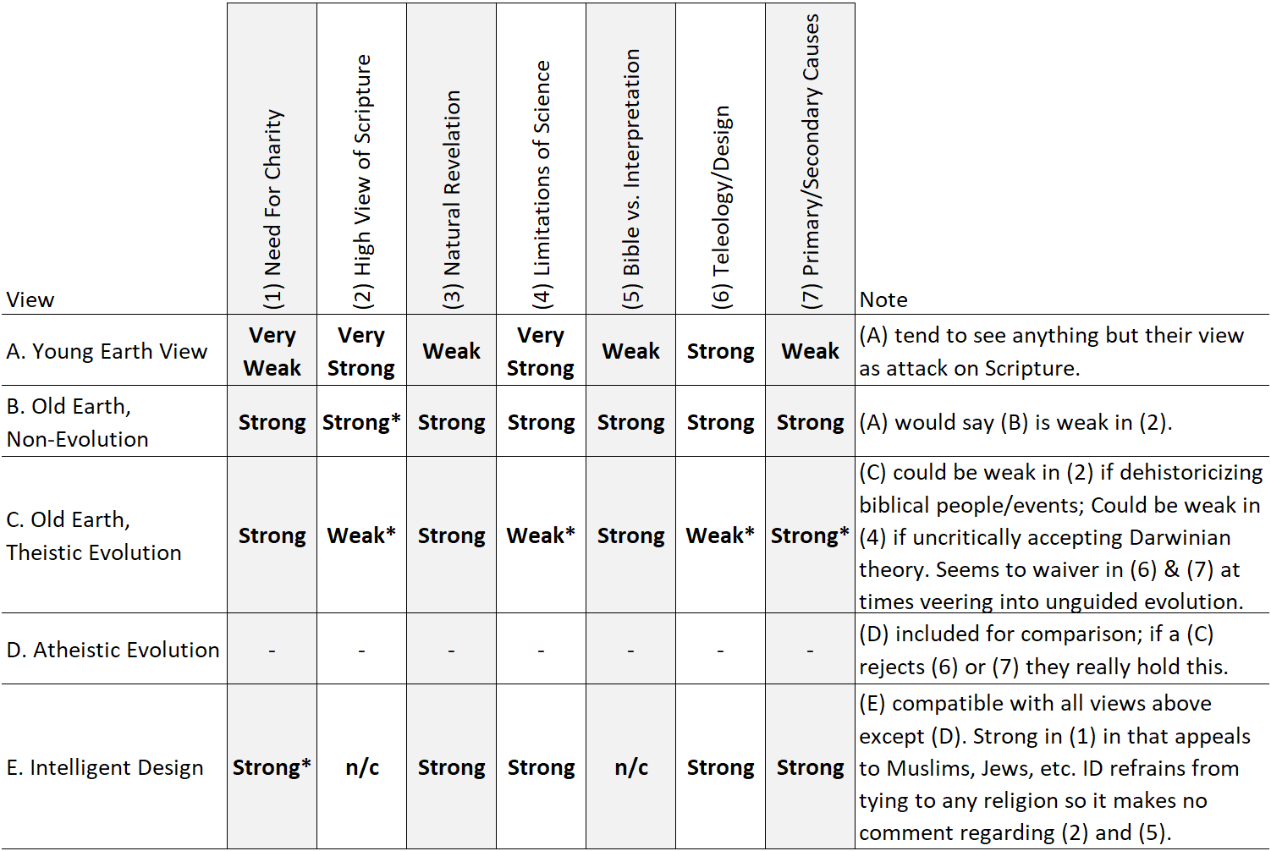

Evaluating the Young Earth View (A)
The Young Earth view is very strong on points two, four and six but weak on points one, three and five. Young Earthers claim to be most faithful to the Bible (point two). They typically will hold to full inerrancy and a very high-view of Scripture. They reject any attempt to dehistoricize people, places or events mentioned in Scripture. They are also quick to acknowledge the limitations of science (point four). For example, they often point to evidence of strong bias in radiometric dating techniques or anomalies found with archaeological strata that argue for rapid sedimentation. Young Earthers affirm God is an intentional Creator who directly created all lifeforms in kinds at the beginning (things did not gradually evolve). Thus, everything is seen as having distinct essence and a purpose/place within God’s created order (point six).
Young Earthers, however, tend to be the least charitable. In their zeal for protecting the Word of God from what they feel is compromise, they tend to personally attack proponents of the other views. Some (but not all) tend to downplay the validity of science as a means of clarifying Scripture. They tend to think their view is the only possible valid interpretation of the “Word of God.”
Young Earthers’ zeal for a high-view of Scripture is commendable. However, it comes at the expense at times of charity. Young Earthers (of which I am/was) would do well to remember that science really can help shed light on the proper interpretation of biblical passages,and remember to have charity in the areas of secondary issues. They should recognize that believing in an Old Earth is not necessarily some liberal conspiracy to water down a high-view of Scripture (ninety-percent of the signers of the ICBI were Old Earth).

Evaluating the Old Earth, Non-Evolution View (B)
In my estimation, proponents of the Old Earth, Non-Evolution view are strong in all areas and weak in none. However, Young Earthers would say they are weak in point two (they are charged with “compromising” the Bible to fit dubious scientific models).

Evaluating the Old Earth, Theistic Evolution View (C)
The Old Earth, Theistic Evolutionist view is very strong on points one, three five and seven but weak in points two, four and six. They are strong on recognizing the need for charity (point one). They do place much value in science as a valid means of knowing truth (point three). And they recognize the difference between primary and secondary causes—this really being foundational to their view.
However, of the three views, this view seems the riskiest to me. There is a sense that too much weight is given to science and that evolutionary theory is uncritically accepted without challenge. Some are quick to dehistoricize people like Adam and Eve and this comes at the expense of the Bible (point two). Macro-evolutionary theory seems to conflict with statements about God creating “in kinds” and that things have real essence and identity (point six). At times it’s unclear how transcendent God is in his guidance of evolution (point seven). And this view could quickly collapse into deism if God’s guidance is too far removed.

Atheistic / Naturalistic Evolution (D)
This is included to help clarify the Old Earth, Theistic Evolution position (C) above. If a (C) holds to unguided evolution (they reject point six or seven) then they really hold to this.

Intelligent Design (E)
Intelligent Design is compatible with all views above except Naturalistic Evolution (D). It is strong in having charity (point one)—it is so charitable that even Muslims and Jews feel at home. It is highly scientific (point three). It is strong in acknowledging the limitations of science (point four), teleology (point six) and identifying primary and secondary causes (point seven). Since Intelligent Design does not want to align itself with any religion, it makes no comment regarding Scripture (point two) and the Bible vs. interpretation (point five).

Conclusion
I assume there will be readers who disagree with me on my list on safety rails. Some might see that the rails seem to mark out an area favorable to view (B) Old Earth, Non-Evolution. And for this reason, they might reject the entire exercise represented in this paper. Others might see a legitimately important safety rail that I simply failed to mention. I think it would be unrealistic for me to think I could generate something that we could all agree on. But my sincere hope is that the thinking that has gone into this paper would help others see that there is some freedom to move inside the creation debate, but that we should also acknowledge there are assumptions that go along with each view. And we should avoid assumptions that are destructive to ourselves and others. Towards this end, let us resist any urge to climb over the safety rails.

Bibliography
Baker, Thomas William. “Thomistic Teleology in the Philosophy of Nature with Its Theological and Moral Implications.” PhD diss., Southern Evangelical Seminary, 2018.
Chalmers, Alan F. What Is This Thing Called Science? 4th ed. Indianapolis/Cambridge: Hackett Publishing Company, Inc., 2013.
Farnell, F. David, Norman L. Geisler, Joseph M. Holden, William C. Roach, and Phil Fernandes, eds. Vital Issues in the Inerrancy Debate. Eugene, OR: Wipf & Stock, an Imprint of Wipf and Stock Publishers, 2016.
Geisler, Norman L. Christian Ethics: Contemporary Issues and Options. 2nd ed. Grand Rapids, Mich.: Baker Academic, 2010.
––––––. “Reviews [of the Views of Creation].” Christian Apologetics Journal 11, no. 2 (Fall 2013): 167-74.
––––––. Systematic Theology, Volume Two: God, Creation. Minneapolis, MN: Bethany House Publishers, 2003.
––––––., and F. David Farnell, eds. The Jesus Quest: The Danger from Within. Xulon Press, 2014.
––––––., and Frank Turek. I Don't Have Enough Faith to Be an Atheist. Wheaton, Ill.: Crossway, 2004.
––––––., and R. C. Sproul. Explaining Biblical Inerrancy: Official Commentary on the ICBI Statements. Matthews, NC: Bastion Books, 2018.
––––––., and Ron Rhodes. Conviction Without Compromise. Eugene, OR: Harvest House Publishers, 2008.
––––––., and Ronald M. Brooks. Come, Let Us Reason: An Introduction to Logical Thinking. Grand Rapids, Mich.: Baker Academic, 1990.
Ham, Ken, Hugh Ross, Deborah B. Haarsma, and Stephen C. Meyer. Four Views on Creation, Evolution, and Intelligent Design. Grand Rapids, Michigan: Zondervan, 2017.
Hannah, John D., ed. Inerrancy and the Church. Chicago: Moody Press, 1984.
Howe, Richard G. “Classical Apologetics and Creationism.” Christian Apologetics Journal11, no. 2 (Fall 2013): 5-31.
Meyer, Stephen C. Darwin's Doubt: The Explosive Origin of Animal Life and the Case for Intelligent Design. Revised ed. New York: HarperOne, 2014.
Oderberg, David S. Routledge Studies in Contemporary Philosophy. Vol. 11), Real Essentialism. New York: Routledge, 2008.
Pearcey, Nancy R., and Charles B. Thaxton. The Soul of Science: Christian Faith and Natural Philosophy. Wheaton, Ill.: Crossway Books, 1994.
Pratico, Gary D., and Miles V. Van Pelt. Basics of Biblical Hebrew: Supplemental Laminated Chart. Grand Rapids: Zondervan, 2007.
Sarfati, Jonathan. Refuting Compromise: A Biblical and Scientific Refutation of “Progressive Creationism” (Billions of Years) As Popularized by Astronomer Hugh Ross. 2nd ed. Powder Springs, GA: Creation Book Publishers, 2011.
Wallace, William A. The Modeling of Nature: Philosophy of Science and Philosophy of Nature in Synthesis. Washington, D.C.: The Catholic University of America Press, 1996.

Ham in Ken Ham et al., Four Views on Creation, Evolution, and Intelligent Design (Grand Rapids, MI: Zondervan, 2017), 18.
Some (but not all) believe no death of any species at all, e.g., insects.
Ham, Four Views on Creation, 19.
Not all Young Earthers believe this point.
Ham, Four Views on Creation, 13.
Adapted from Norman L. Geisler, Systematic Theology, Volume Two: God, Creation (Minneapolis, MN: Bethany House Publishers, 2003), 644–646 and Hugh Ross in Ken Ham et al., Four Views on Creation, 72.
Deborah Haarsma in Ken Ham et al., Four Views on Creation, 125.
Christianity requires the miracle of the resurrection of Christ from the dead. In deism, there are no miracles. With atheism, there is no God. Hence, Christianity is only compatible with the belief in a transcendent God who is also immanent and performs miracles (theism).
For a good book on Intelligent Design see Stephen C. Meyer, Darwin's Doubt: The Explosive Origin of Animal Life and the Case for Intelligent Design, Revised ed. (New York: HarperOne, 2014).
While some do argue that compromises with the Genesis record could lead to a compromise in the Gospel, Young Earthers, Old Earthers and Theistic Evolutionists who trust in the finished work of Christ upon the cross meet the requirements for salvation.
For more on primary and secondary issues see Norman Geisler and Ron Rhodes, Conviction Without Compromise (Eugene, OR: Harvest House Publishers, 2008).
The formula I used for mathematically calculating the number of possible combinations is: 3x4x2x2x3x3x3x4x2x2x2x2x3x3x3x3x4x2x2x2x2x2x2x2x2x2x2x4x3x4x2x2x2x3x2x3x2x2x2x2x2x2x2x2x2 = 97,387,593,162,817,536.
Ethical portion adapted from Norman L. Geisler, Christian Ethics (Grand Rapids, MI: Baker, 2010).
Deborah Haarsma in Ken Ham et al., Four Views on Creation, 126, 147.
I’m convinced this charity will play itself out in meekness and humility. The Bible says it is important to have meekness, humility and charity towards unbelievers (1 Pet. 3:15). How much more should we have these with fellow believers! (Mt. 11:29)
Norman L. Geisler and William E. Nix, A General Introduction to the Bible, Rev. and expanded. (Chicago: Moody Press, 1986), 87.
The International Council of Biblical Inerrancy produced a whole book titled Inerrancy and the Church that demonstrates this point. See John D. Hannah, ed., Inerrancy and the Church (Chicago: Moody Press, 1984).
F. David Farnell et al., eds., Vital Issues in the Inerrancy Debate (Eugene, OR: Wipf & Stock, 2016), 22.
Nancy R. Pearcey and Charles B. Thaxton, The Soul of Science: Christian Faith and Natural Philosophy (Wheaton, Ill.: Crossway Books, 1994), 17.
Ibid., 19.
Ibid., 41.
Ibid., 35.
All people are said to be aware of God’s existence. In Rom. 1:20 it says the knowledge of general revelation is clearly perceived. And the fact that it perceived but not received becomes the basis of God’s judgment (Rom. 2:15).
Richard G. Howe in “Classical Apologetics and Creationism,” Christian Apologetics Journal 11, no. 2 (Fall 2013): 5-31, 28. It is being reported from the perspective of the observer (phenomenological language).
Norman L. Geisler, “Reviews [of the Views of Creation],” Christian Apologetics Journal 11, no. 2 (Fall 2013): 167-74, 170. This is a metaphorical description or perhaps an idiom.
Howe in “Classical Apologetics and Creationism,” 12. This is also metaphor.
There is a debate today about what “science” even is; therefore “science” is put in quotations here.
Alan F. Chalmers, What Is This Thing Called Science? 4th ed. (Indianapolis/Cambridge: Hackett Publishing Company, Inc., 2013), 18.
Pearcey, 117.
William A. Wallace, The Modeling of Nature: Philosophy of Science and Philosophy of Nature in Synthesis (Washington, D.C.: The Catholic University of America Press, 1996), 241.
Chalmers, 7.
There’s a helpful Black Swan illustration: I could argue that all swans are white because all swans observed in my backyard are white. But if I were to travel to Australia, I would find black swans. It would be true that all swans in my backyard are white, but it would be going beyond the data to say all swans everywhere are white.
Chalmers, 42, emphasis mine.
Wallace, 233.
Chalmers, 81.
Ibid., 62.
Ibid., 69.
Ibid., 100.
Chalmers, 107.
Much more could be said about how a gestalt switch applies to scientific paradigm acceptance.
Ibid, 107.
Ibid., 121.
Ibid., 123.
Norman L. Geisler and R. C. Sproul, Explaining Biblical Inerrancy: Official Commentary on the ICBI Statements (Matthews, NC: Bastion Books, 2018), 10.
Summary of Figures 1 and 2 by Thomas A. Howe in Norman L. Geisler and F. David Farnell, eds., The Jesus Quest: The Danger from Within (Xulon Press, 2014), Kindle loc. 15794 and 15833.
With idioms, the meaning is not derived from the grammar but is imposed on the text from some pre-agreed understanding between the sender/receiver usually because of popular use in culture (e.g., “What’s up?” means, “Greetings!”). This means that meaning is not always tied to grammar in a strict absolute sense.
This is very relevant in the creation debate because Old Earthers argue that the word “day” is being used in a figurative sense.
Norman L. Geisler and Ronald M. Brooks, Come, Let Us Reason: An Introduction to Logical Thinking (Grand Rapids, Mich.: Baker Academic, 1990),119.
For example, the following exchange between Captain Kirk and Sulu is ambiguous as we move from its literary to logical form. Kirk says, “I need a computer! Are all the computers broken?” Sulu responds, “All the computers are not broken, captain!” But what does this mean? It can mean that “some computers are not broken (but others are)” or it can mean “none of the computers are broken.” It depends on whether Zulu meant for the “all” to modify “computers” (adjectivally) or “are” (adverbially) in his response.
Koine Greek is a grammatically precise language. However, judgment calls still need to be made to determine meaning. A good example is with the genitive case function found in Rom. 5:5: “the love of God [ἡ ἀγάπη τοῦ Θεοῦ] has been poured out in our hearts by the Holy Spirit.” If Paul meant “of God” to be an objective genitive, then he meant “love for God has been poured out in our hearts” (i.e., God has put attraction for Himself into our sinful hearts). But if he meant “of God” to be a subjective genitive then he meant “God’s love has been poured out in our hearts” (i.e., God fills us with His very own love/charity for others). Judgment calls cannot be avoided in Hebrew grammar as well. For example, there are five basic uses of the infinitive construct: (1) it could express purpose, (2) indicate an action is about to take place, (3) simply functions as a noun, (4) clarify something or (5) indicate a temporal clause (e.g., “while” or “when”). See Gary D. Pratico and Miles V. Van Pelt, Basics of Biblical Hebrew: Supplemental Laminated Chart (Grand Rapids: Zondervan, 2007), 4. This likely makes little sense to anybody who has not studied Hebrew or Greek. But for those who have, they are fully aware that the great difficulty in studying these languages is memorizing and remembering all the rules of grammar.
Geisler and Sproul, Explaining Biblical Inerrancy, 10.
Ibid, 21, Article XXII.
David S. Oderberg, Routledge Studies in Contemporary Philosophy, vol. 11), Real Essentialism (New York: Routledge, 2008), 18.
Thomas William Baker, “Thomistic Teleology in the Philosophy of Nature with Its Theological and Moral Implications” (PhD diss., Southern Evangelical Seminary, 2018), 62.
Real essentialism is here contrasted with reductionism.
Oderburg, 194.
Baker, 90.
Baker, 222.
Michael Behe coined the phrase “irreducible complexity.” Stephen Meyer and William Demski are known for specified complexity.
The self-assembling ability of matter cannot be emphasized to the point where God is completely transcendent or this view collapses to deism, and this is not fitting for Christians, as already explained.
There is more to naturalistic evolution than merely biological evolution. There is cosmic evolution (the origin of matter), chemical evolution (origin of life from non-life) and biological evolution (origin of complex life from “simple” life). See Norman L. Geisler and Frank Turek, I Don't Have Enough Faith to Be an Atheist (Wheaton, Ill.: Crossway, 2004).
Norman L. Geisler, Systematic Theology, Volume Two: God, Creation (Minneapolis, MN: Bethany House Publishers, 2003), 505, 506.
Some icons made by Pixel Perfect and Freepik; flaticon.com is licensed by CC 3.0 BY.
For the first twenty-five years of my Christian walk, I was a Young Earther (I still might be one). I myself was very uncharitable towards Old Earthers and personally understand how it feels to want to protect the Bible from people who want to “twist Scripture!”
It’s very important to remember the discussion from Rail 3: science helps clarify that the Bible cannot be teaching the sun revolves around a square earth that has trees with hands.
Jonathan Sarfati, Refuting Compromise: A Biblical and Scientific Refutation of “Progressive Creationism” (Billions of Years) As Popularized by Astronomer Hugh Ross, 2nd ed. (Powder Springs, GA: Creation Book Publishers, 2011), Kindle loc. 1398-1401.
Ibid., Kindle loc. 1427-1429.
We could humorously add my list of seven safety rails to Illustration 2, making it even less likely somebody would ever completely agree with me!

